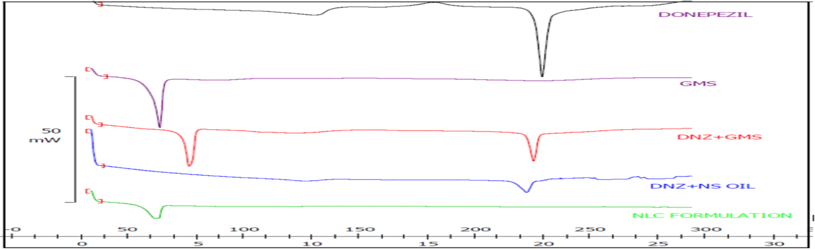

**Fig 1: Overlay Thermograms of a) Donepezil b) GMS c) DNZ+GMS**

**d) DNZ+ NS oil e) NLC formulation**

**Table1: Formulation Batches by using Design of Expert Software**

|  |  |  |  |  |  |
| --- | --- | --- | --- | --- | --- |
| RUN | **Factor A**  **(Drug: Lipid ratio)** | **Factor B**  **(SL: LL)** | **Factor C**  **(Surfactant concentration)** | **Ingredients** | **Ratios /Concentrations** |
| 1 | -1 | 1 | -1 |  |  |
| 2 | 1 | 1 | 1 | Drug : polymer ratio | 1:4 ; 1:6 |
| 3 | -1 | -1 | 1 | Solid lipid : Liquid lipid | 70:30 ; 80:20 |
| 4 | -1 | -1 | -1 | Surfactant | 1% or 3% |
| 5 | 1 | -1 | 1 | Co-surfactant | 0.5% |
| 6 | 1 | -1 | -1 |
| 7 | **-1** | **1** | **1** |
| 8 | 1 | 1 | -1 |

**Table2: Formulation composition and characterization of DNZ NLC formulation.**

|  |  |  |  |  |  |  |
| --- | --- | --- | --- | --- | --- | --- |
| RUN | X1  (Drug: Lipid ratio) | X2  (SL: LL) | X3  (Surfactant Conc) | Response 1  Particle size (nm) | Response 2  ZP (mV) | Response 3  EE (%) |
| F1 | -1 | 1 | -1 | 139.4±0.9 | -23.4 | 65.32±0.999 |
| F2 | 1 | 1 | 1 | 85.3±2.23 | -38.6 | 66.52±0.577 |
| F3 | -1 | -1 | 1 | 331.1±18.30 | -34.2 | 64.47±0.577 |
| F4 | -1 | -1 | -1 | 217.2±7.95 | -41.1 | 65.76±0.577 |
| F5 | 1 | -1 | 1 | 201.4±12.45 | -33.4 | 64.90±0.577 |
| F6 | 1 | -1 | -1 | 94.1±2.90 | -31.9 | 69.00±0.577 |
| F7 | -1 | 1 | 1 | 107.4±2.64 | -41.7 | 70.20±0.577 |
| F8 | 1 | 1 | -1 | 181.5±8.75 | -39.1 | 65.11±1.154 |

 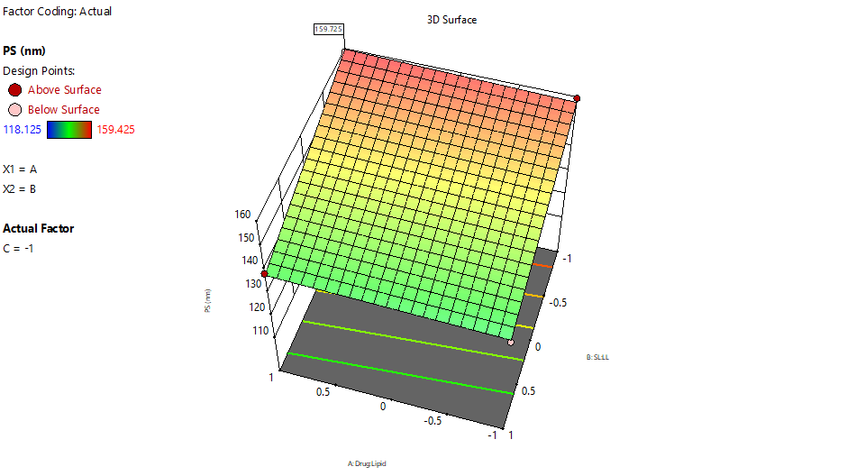 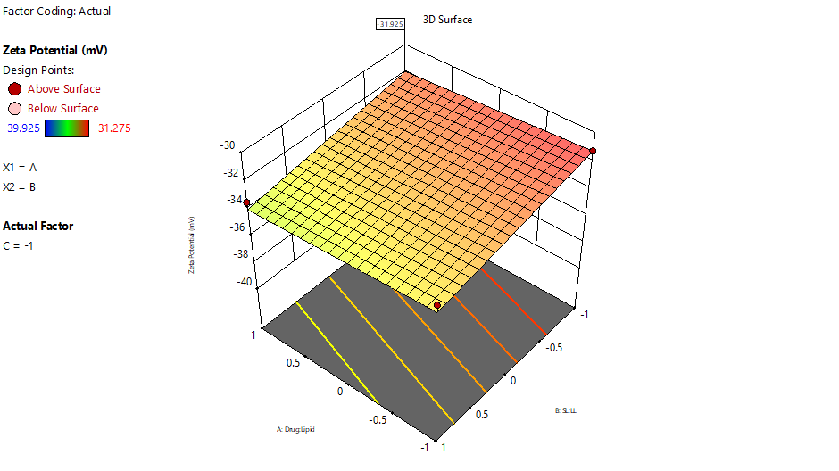

**Fig2: 3D surface plot for effect of independent variables on particle size, Zeta potential & EE of optimized formulation**

**Figure 3: %CR Graph of Optimized formulation**

**Fig 4(a): Pharmacokinetic profiles of brain (concentration against time profile) for DNZ solution & DNZ-NLC delivered through IV & IN respectively**

**Fig 4(b): Pharmacokinetic profiles of blood (concentration against time profile) for DNZ solution & DNZ-NLC delivered through IV & IN respectively.**

**Table 3: Pharmacokinetic parameters of optimized DNZ NLC formulation**

|  |  |  |  |
| --- | --- | --- | --- |
| Pharmacokinetic parameter | Tissue | Intravenous route | Intranasal route |
|  |  |  |  |
| Cmax(ug/ml) | Brain | 1.0258 | 4.597 |
|  | Blood | 5.83305 | 2.2583 |
|  |  |  |  |
| Tmax(h) | Brain | 2 | 1 |
|  | Blood | 0.25 | 1 |
|  |  |  |  |
| AUClast(ug/uL*h) | Brain | 0.00178699 | 12.0606 |
|  | Blood | 0.00964078 | 0.00481891 |
|  |  |  |  |
| AUCextra(ug/uL*h) | Brain |  | 3.51097 |
|  | Blood | 0.00668131 | 0.00273574 |
|  |  |  |  |
| MRT(h) | Brain |  | 3.5128 |
|  | Blood | 3.37226 | 2.93487 |